- Purpose
  - The purpose of this document is to describe the procedure for assembling the Head Lift on the Genesys Machine.
- Scope
  - This SOP applies to all equipment assembly team members. The process applies to the following machine ID’s:
EP50288EQS0600BE1200 – Head Lift Assembly
- Responsibilities
  - The operations manager/supervisor is responsible for enforcing this SOP.
- Materials
  - The proper materials needed for this process are listed on the machine work order.
- Definitions

- Procedure
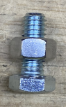
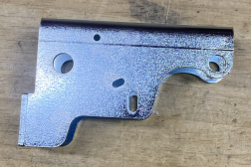
  - Place an Actuator Pivot (E28867) on the table. Take bolt (E81089) and thread a nut (E12524) onto it. Put some Blue Loctite on the end of the bolt and thread bolt into the pivot until there are two threads on the end then stop. The Loctite should hold the bolt in the threaded hole and it should hold the nut on the bolt. Next tighten nut.
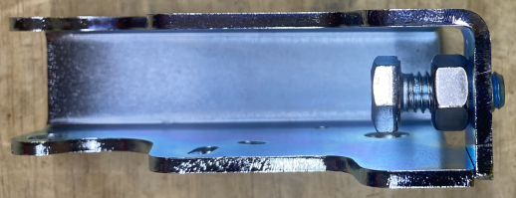

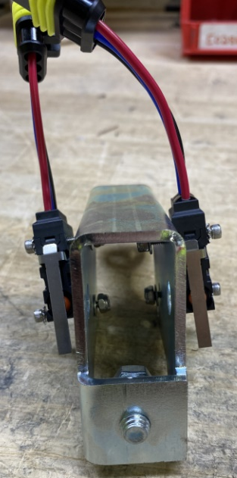
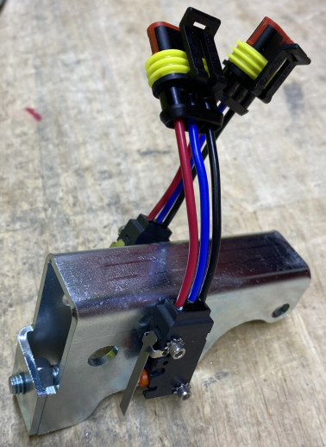
  - Attach a switch (E20704) to the actuator pivot using 2 screws (E28769), 2 lock washers (E28821), 2 washers (E29368) and 2 nuts(E28770). Repeat this step for switch on the other side of actuator. Note: After tightening screws back off two rotations so switch are moveable.

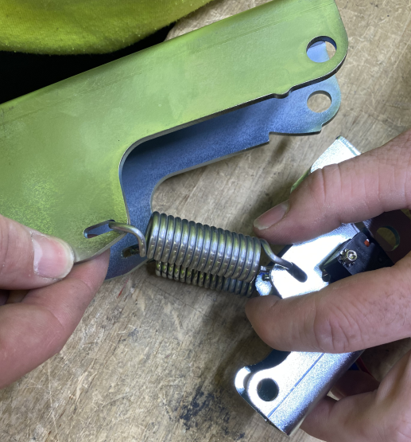
  - Attach 2 springs (E81530) between the pivot and the tower (E28866). This is easiest if one is placed on the actuator pivot and the other on the actuator tower to start. You can then attach the opposite ends.
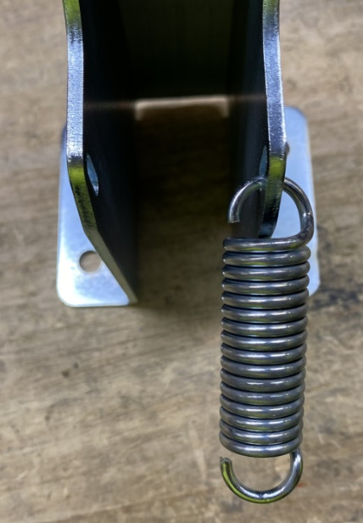
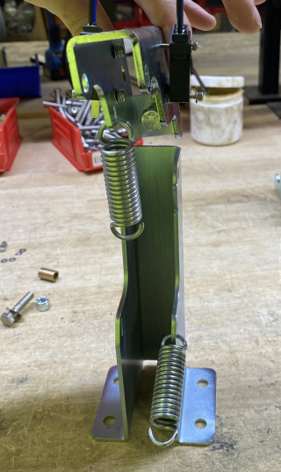

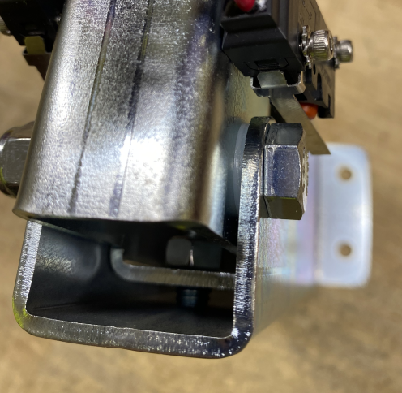
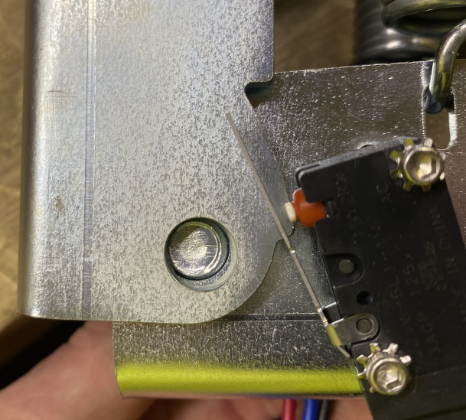
  - With the actuator tower standing up on table, attach the pivot using a bolt (E87644). Place 2 washers (E28830) on each side of the pivot in between the tower and pivot. Place nut (E11146) on end of bolt and tighten. The nut should be tightened enough so that the pivot rotates freely yet does not have any side-to-side movement. If it moves side to side, then it will have issues contacting the switches.
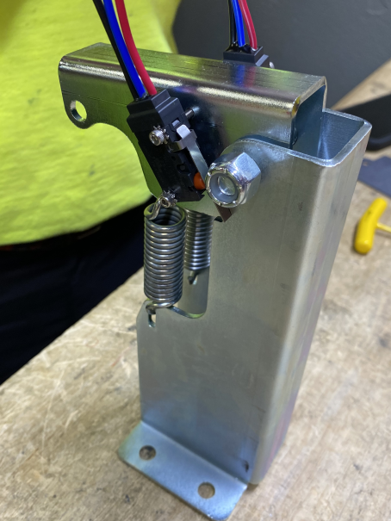
Washers

  - Clamp the tower station to the table and adjust the switch shown in the photo. This switch triggers low down pressure. What you will notice is that there is a small window of rotation of the pivot between when it is all the way down (against the stop bolt) and when the springs catch and begin to create tension. Essentially, this window is the “slack” area where there is no tension on the springs. The low down pressure switch needs to engage (mechanically open) in this window. The switch simply needs adjusted so that it open and closed back up in this window. This may take a couple tries. Ensure the switch screws are fully tightened when complete.
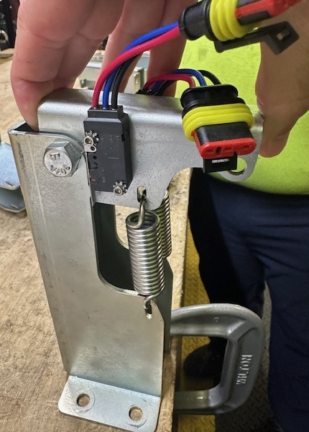

  - To set the medium down pressure switch, push the pivot all the way down so that it is resting on the stop bolt. Take a 0.030” shim and place it between the switch arm and the profile on the tower. Rotate the switch towards the shim until it is completely pressed against it. Tighten the switch in place.

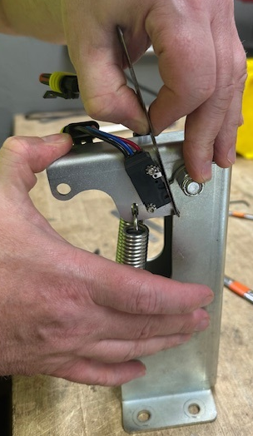

  - Remove the shim and rotate the pivot bracket upwards and ensure that both the low and medium down pressure switch engage (open) at the correct times. If the medium down pressure switch engages too early, loosen the switch, reduce the shim by a couple of thousandths, and reset the switch. Once it is reset tighten it and try again. If the switch engages too late, loosen the switch and add a couple of thousandths to the shim, and reset the switch. Continue until it engages at the correct position. Once done, fully tighten the switch.

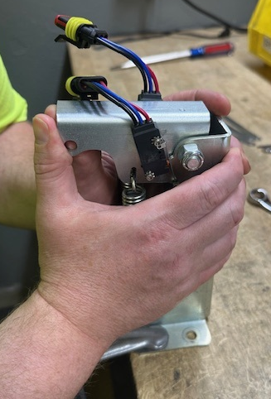
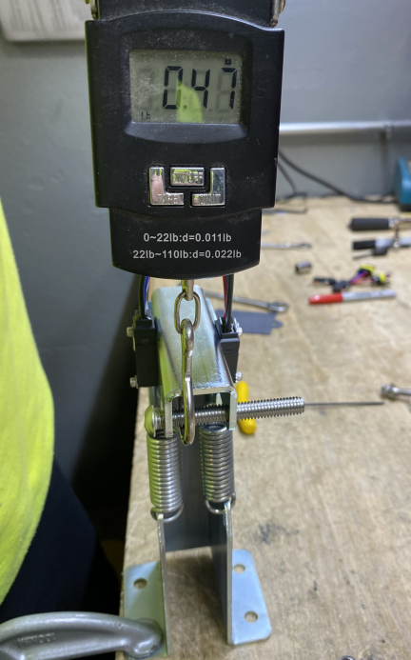
  - As a method to double check the medium down pressure setting, you can use the Mango Spot test on the front of the pivot. Place a bolt through the end of the pivot, hook the meter onto the bolt and pull slowly until you hear the 2nd switch click. Your results should be between 9-14. If the results are not in that area, then you need to re-adjust.

- References (optional section as needed)

- Training Guide

Functional Training Groups Requiring Training
Equipment Assembly Group

- SOP Change Control

Date of Change | Reason for Change
TBD | This is the first version of the S.O.P. hence there are no revisions to this document.
5/15/2025 | Updated for new medium switch setting method
Approvals

Submitter/Author Approval:__________________________________ Date:______________________

Management Approval:______________________________________ Date:______________________

QAU Approval:_____________________________________________ Date:______________________

